Haulin’ ASMR 2019
What a great venue, location and event that took place for ASMR 2019 at the Big Sky Resort in Big Sky, Montana. While the air was thin and the terrain quite different than the previous year in St. Louis, Missouri, a great group again showed up for Haulin’ ASMR. Many similar faces woke up bright and early to meet up, reconnect and introduce themselves to new attendees to ASMR.
While the group did stick to the pavement most days, they did venture up a snowmobile route that wound up and down the mountain side. There were times that the group had to walk and recover from the strains of being at a high altitude. But after it was all said and done, much fun and conversations were had by all.
Attendance varied based who had presentations or other commitments that day. On average, there were 10 participants, each day that met in the lobby of the resort. Participants this year included: Jonathan Bennett (a high school student), Ryan Bennet, Megan Ostrand, Brad Pinno, Curtis Yanish, Evan Hatheway, Sara Kloph, Michele Coleman, Craig Kreman, Drew Herrera, Heather De-Quincey, Rory Doyle, Buck Neely, Ryan Mahony, and Paul Behum.
We are excited for Duluth, Minnesota next year and what trails and roads will be encountered and traversed. An invitation and running shoe reminder will be sent before the 2020 conference. Getting the reminder throughout the winter months is a good motivator for starting or keeping up with a training regime on those cold days.
We look forward to seeing everyone, especially new faces with their running or walking shoes in Duluth.

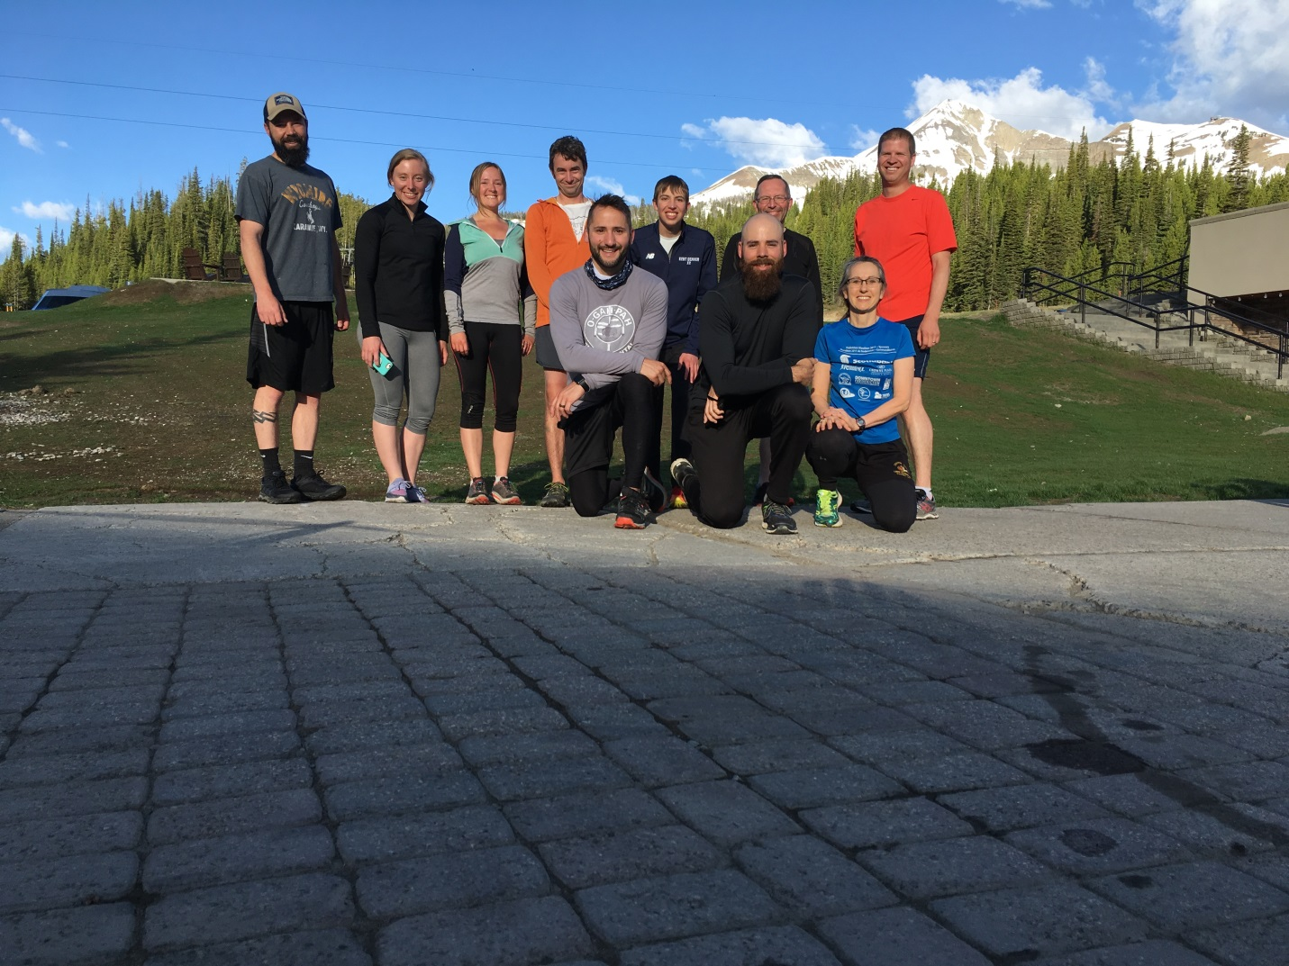
Running the mountain (ha- did not turn out that well)
Drew Herrera, Megan Ostrand, Heather De-Quincey, Rory Doyle, Craig Kreman, Jonathan Bennett, Buck Neely, Ryan Bennett, Michele Coleman, Brad Pinno
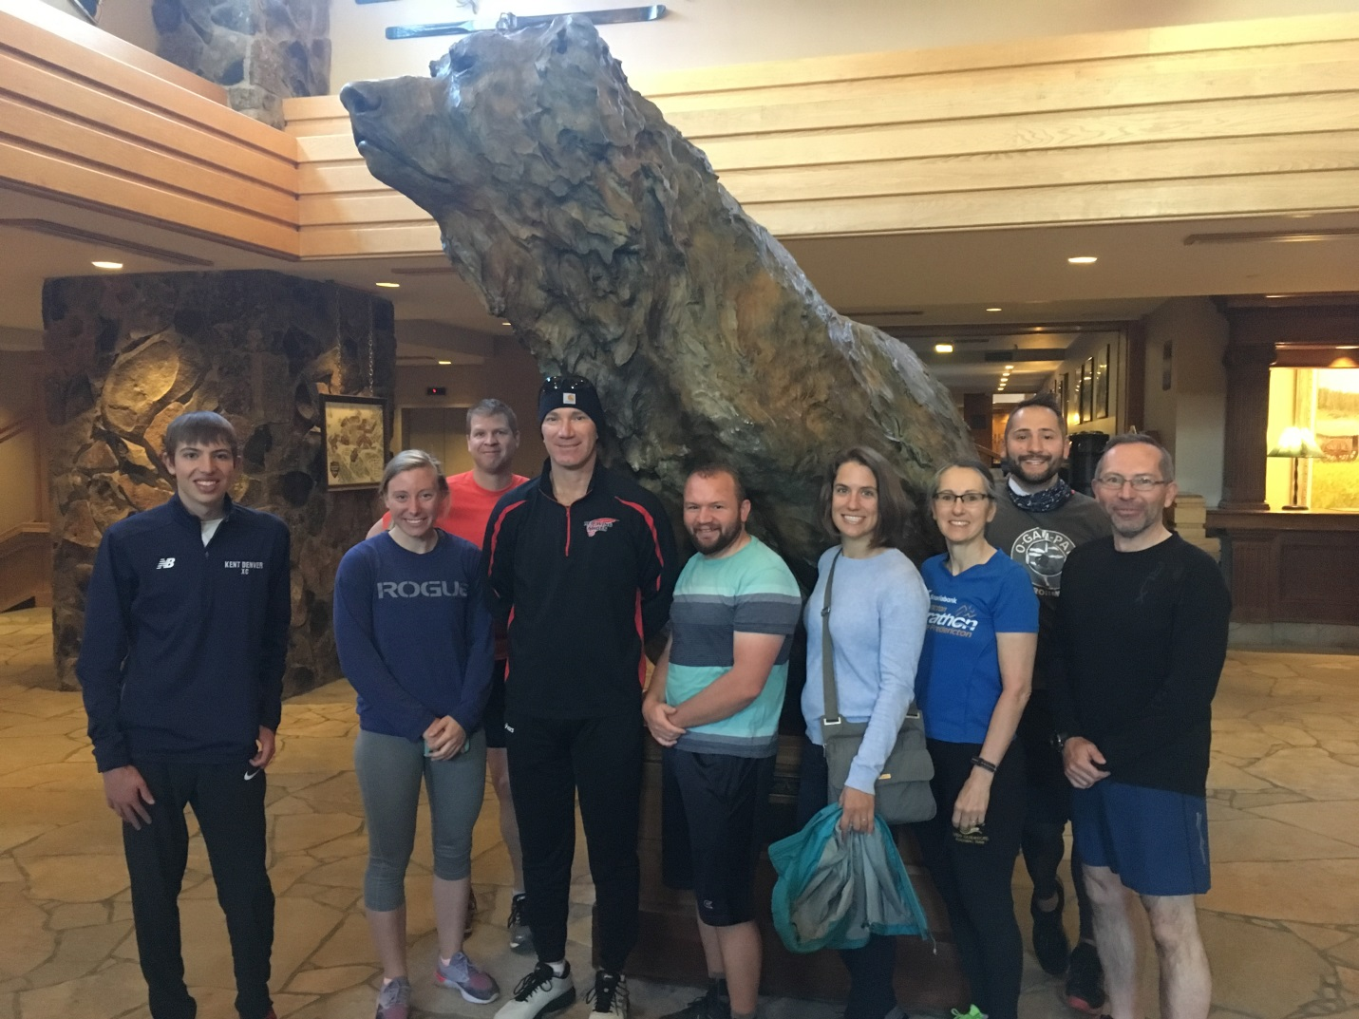
Runners and walkers.
Jonathan Bennett, Megan Ostrand, Brad Pinno, Curtis Yanish, Evan Hatheway, Sara Kloph, Michele Coleman , Craig Kreman, Ryan Bennett
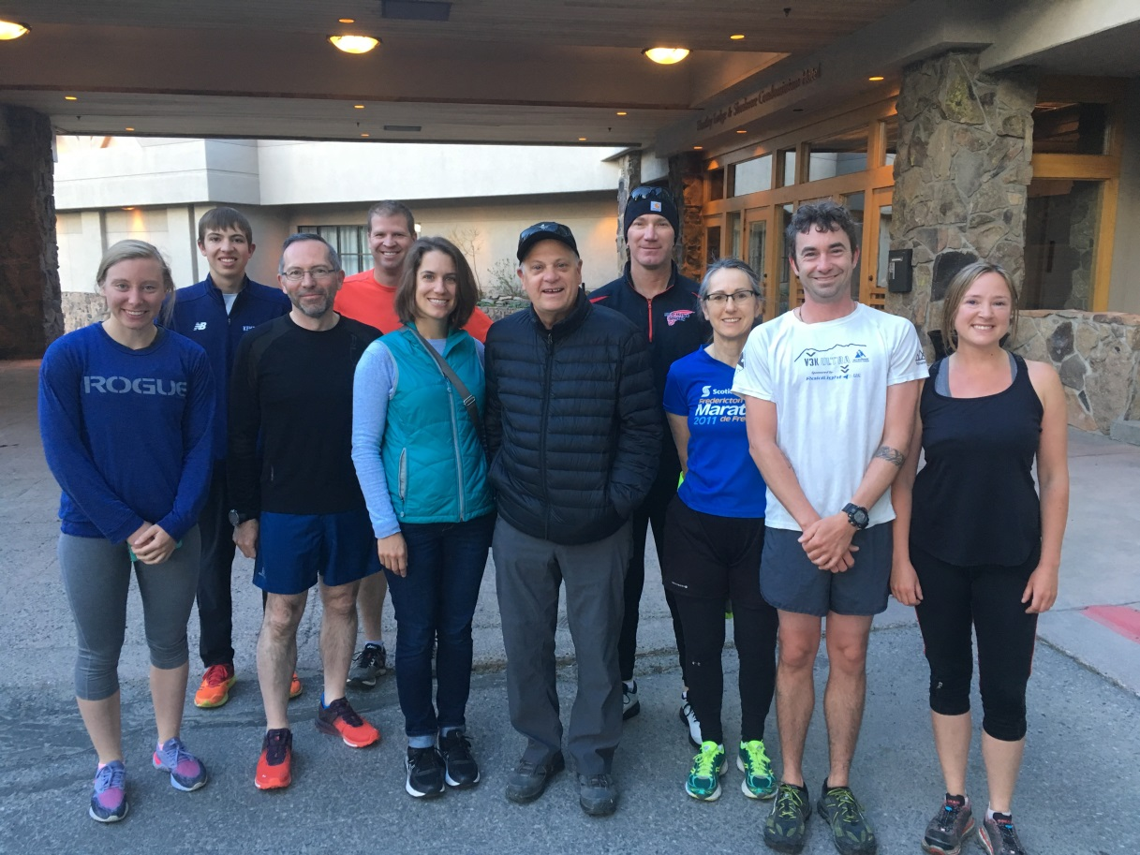
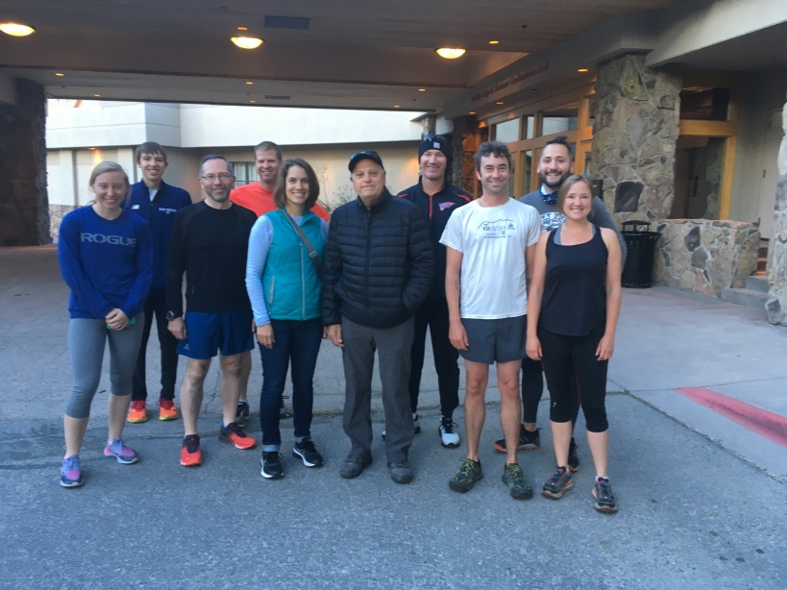This needs to have Craig cropped out and added to the above photo.
Megan Ostrand, Jonathan Bennett, Ryan Bennett, Brad Pinno, Sara Kloph, Paul Behum, Curtis Yanish, Michele Coleman, Rory Doyle,(insert Craig here), Heather De-Quincey

